**4-(5-Phenethoxy-[1,2,4]triazolo[4,3-*a*]pyrazin-3-yl)benzonitrile,** **OSM-S-187**

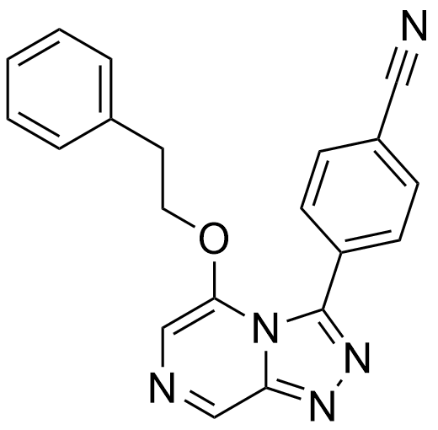

Representative Example: <http://malaria.ourexperiment.org/uri/662>

Prepared according to General Procedure **D** from: **OSM-S-219** (0.20 g, 0.78 mmol, 1.0 equiv.), 2-phenethyl alcohol (0.12 mL, 0.12 g, 1.0 mmol, 1.2 equiv.), KOH (0.15 g, 2.6 mmol, 3.3 equiv.) and 18-crown-6 (20 mg, 80μmol, 0.10 equiv.); 40 ˚C, 1.5 h; purified by automated flash chromatography over silica (Biotage Isolera, 50–100% EtOAc in hexanes) to give the title compound as pale brown needles (85 mg, 32%).

**m.p.** 142–143 ˚C;

**IR** νmax (film) /cm-1 3063, 2228, 1610, 1507, 1297;

**1H NMR** (400 MHz, DMSO-d*6*) δ: 7.19–7.18 (3H, m), 6.92–6.90 (2H, m), 4.54 (2H, t, *J* 6.4), 2.89 (2H, t, *J* 6.4);

**13C NMR** (101 MHz, DMSO-d*6*) δ: 147.6, 144.9, 143.9, 137.2, 134.9, 132.4, 131.5, 131.5, 128.7, 128.2, 126.4, 118.6, 112.2, 109.3, 71.1, 33.7;

**m/z** (APCI+) 342 [M+H]+;

**HRMS** (APCI+) found 342.13477 [M+H]+, C­­­­20H16N5Orequires342.13494;

***Strings:****N#CC(C=C1)=CC=C1C2=NN=C3C=NC=C(OCCC4=CC=CC=C4)N32*

*InChI=1S/C20H15N5O/c21-12-16-6-8-17(9-7-16)20-24-23-18-13-22-14-19(25(18)20)26-11-10-15-4-2-1-3-5-15/h1-9,13-14H,10-11H2*

*ZUPHNBXHMXOSSS-UHFFFAOYSA-N*